Web

Pending

Home profile professional

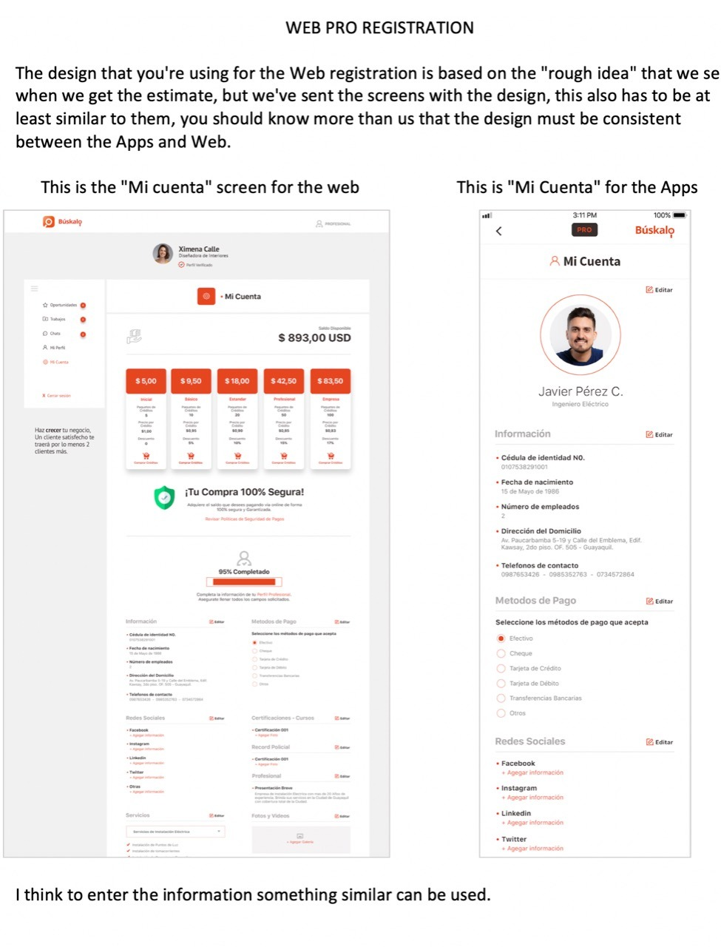

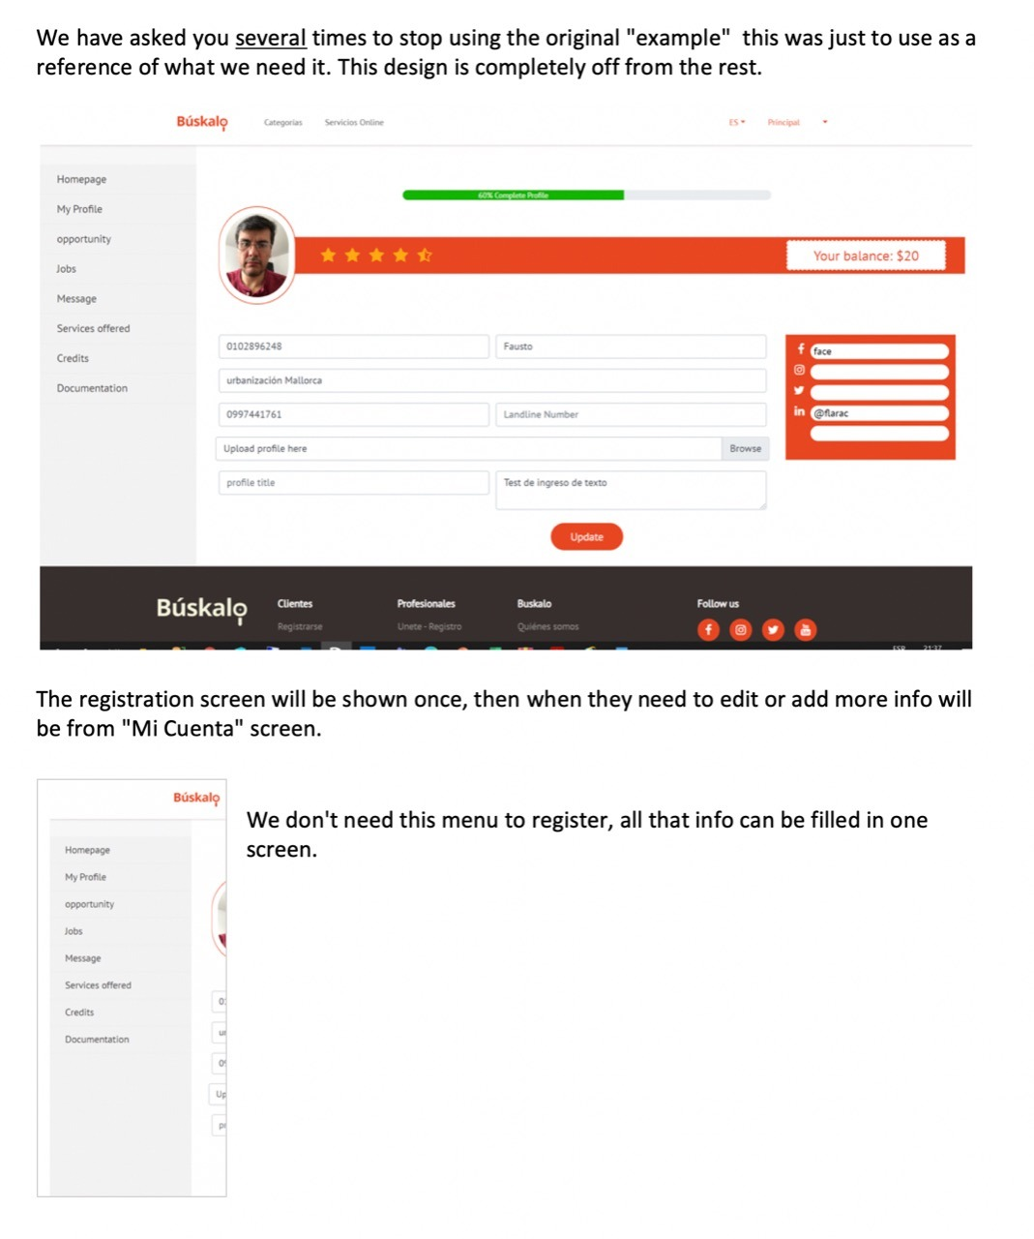

Despite selecting ES, all the labels of the professional's profile are in English

Services

In the profile of the professional, the subservice cannot be selected, this is important that it be handled as it is being done on the mobile

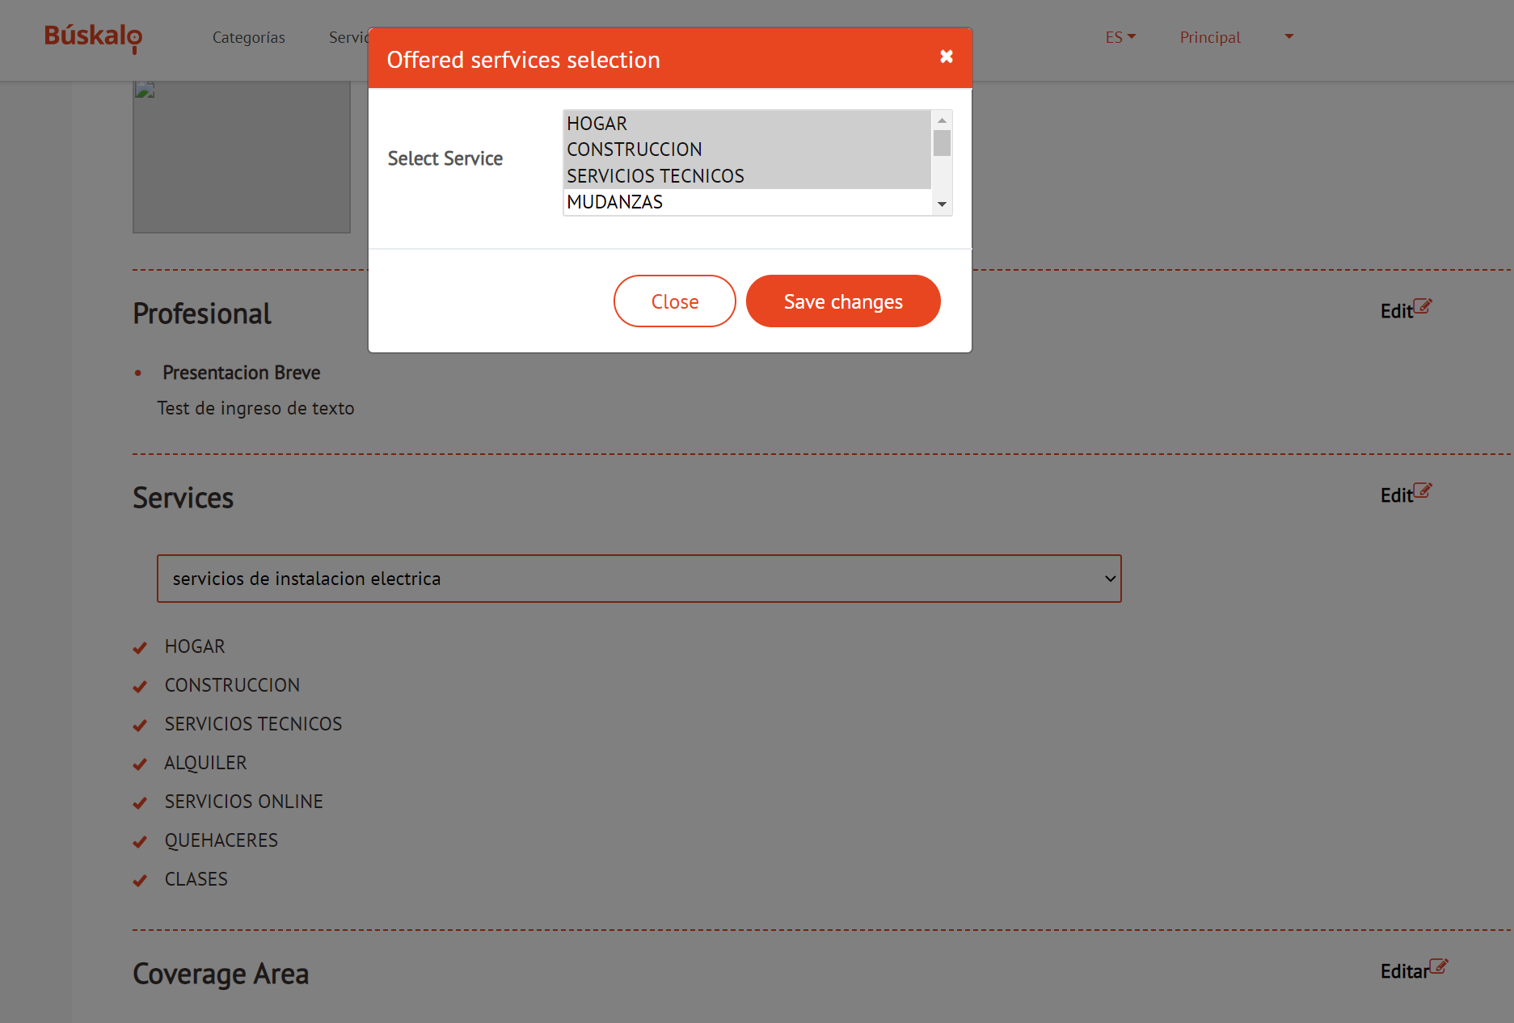

the drop-down list of services what function does it serve?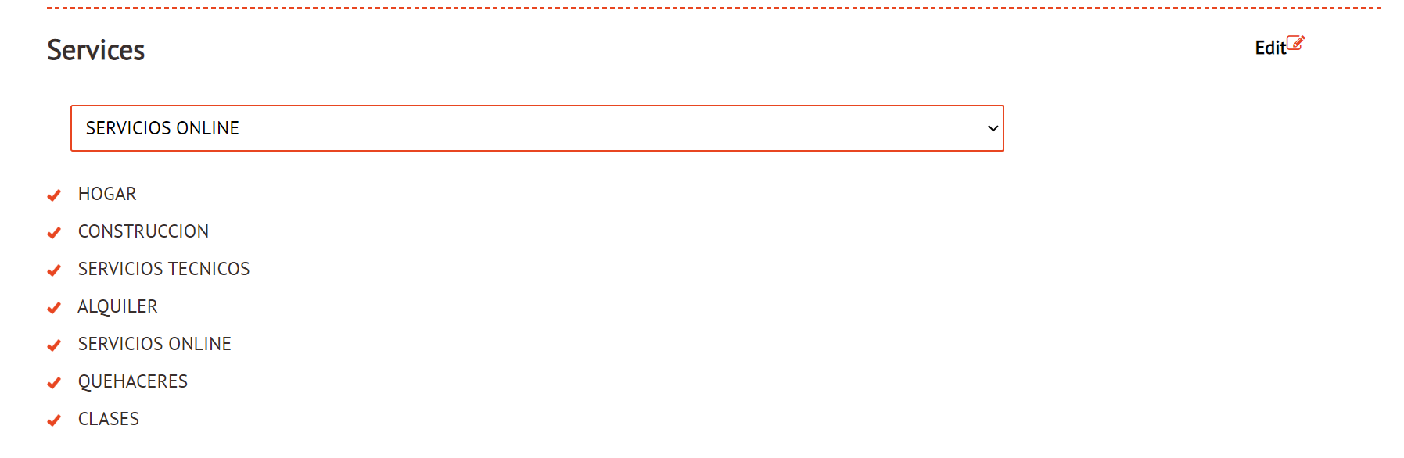

Coverage Area

the selection of the coverage areas must be hierarchical, the cities correspond to the provinces

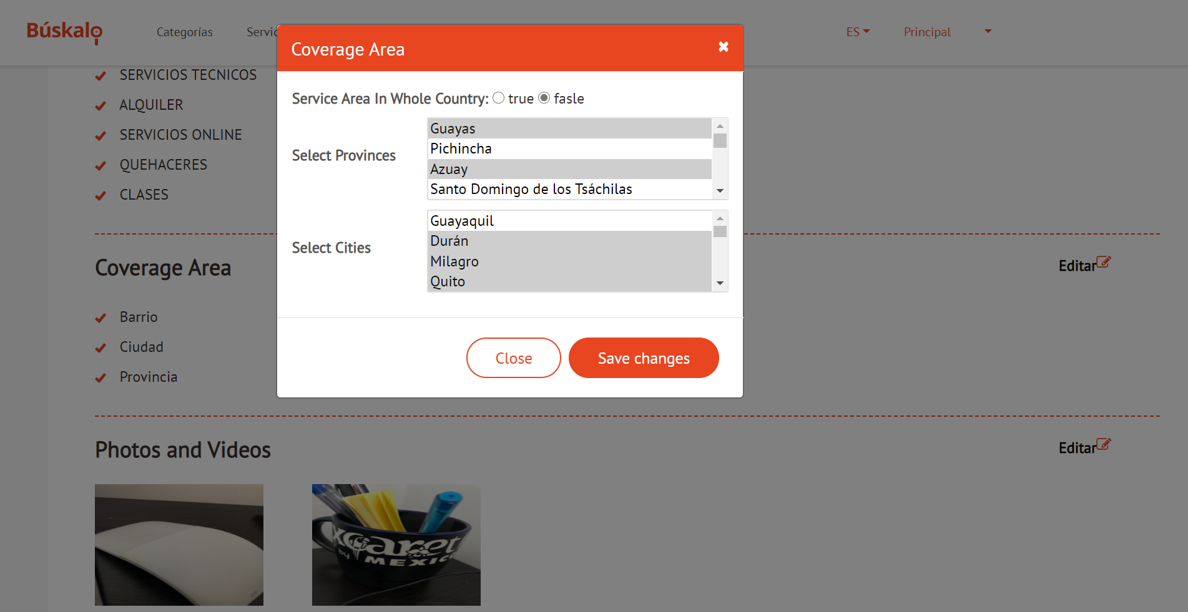

after saving the changes are not reflected in the profile

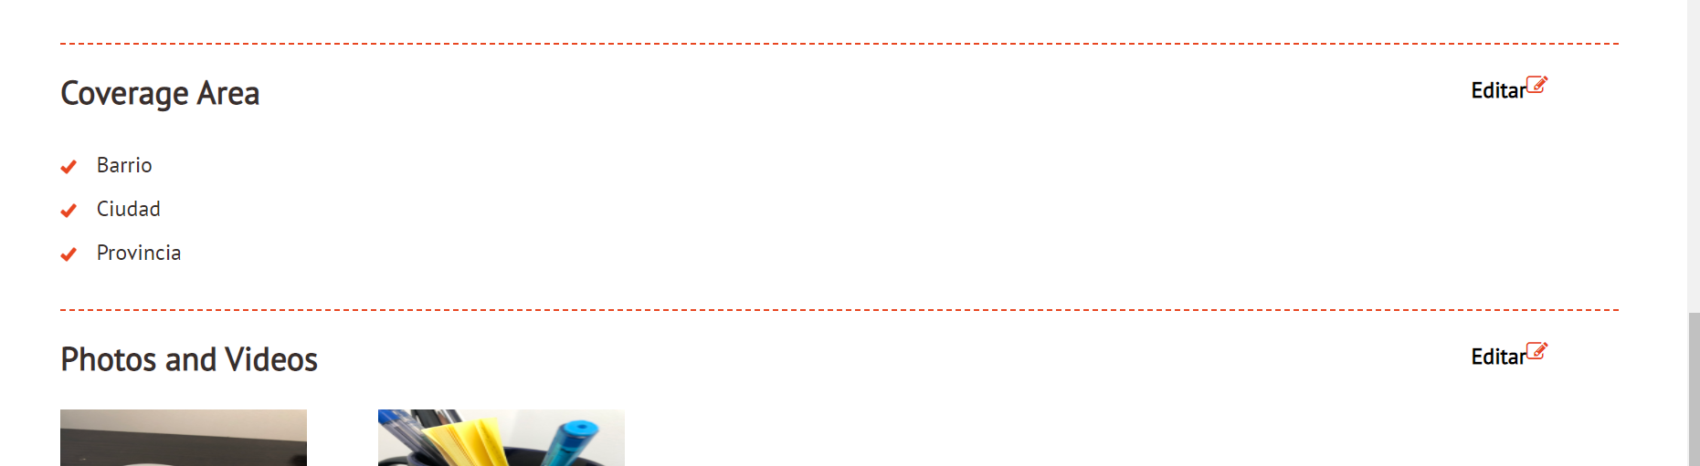

Payment Methods

Multiple options required

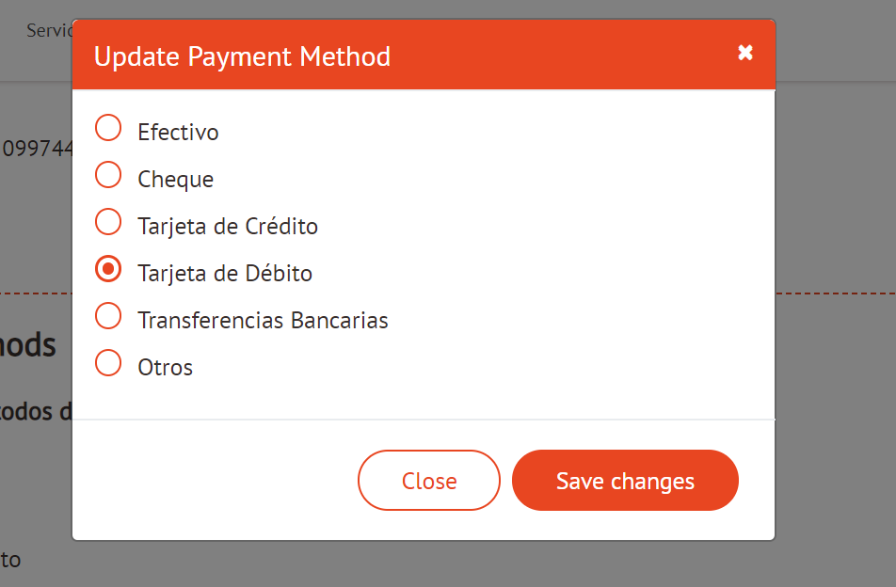

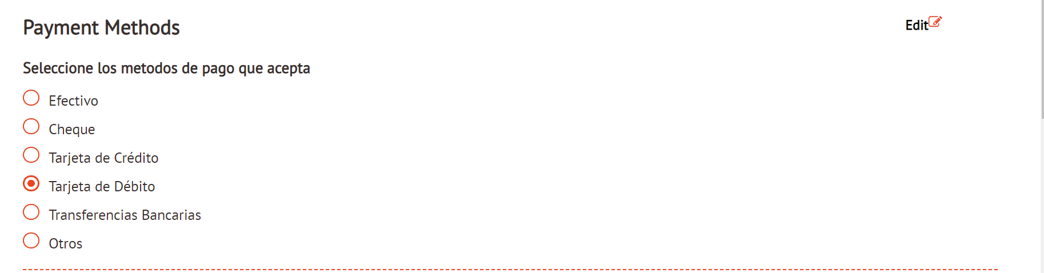

Jobs:

the text box for the search does not perform any action

the filter by work status also does not perform any action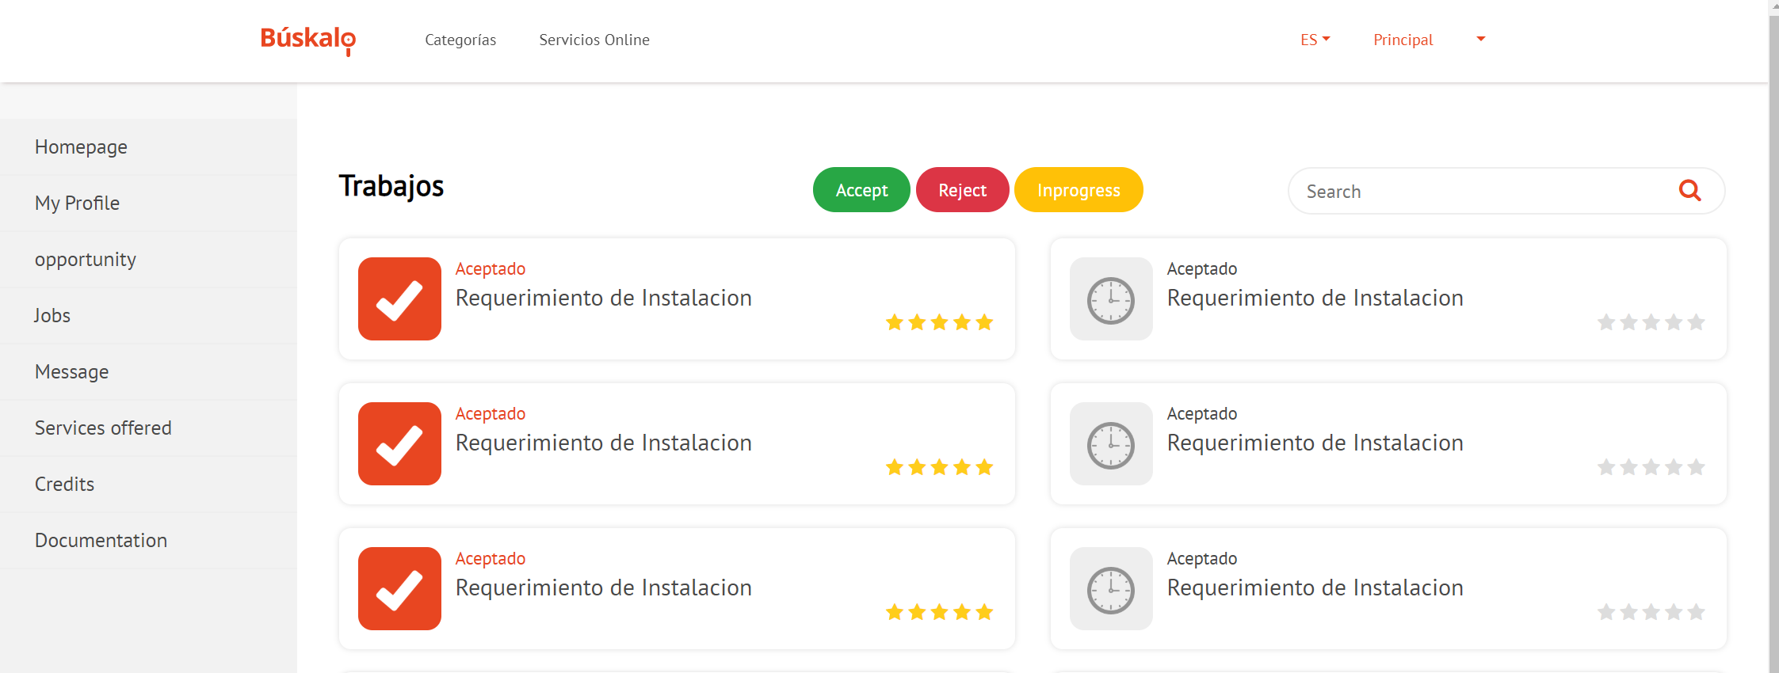

Remove Services offered .

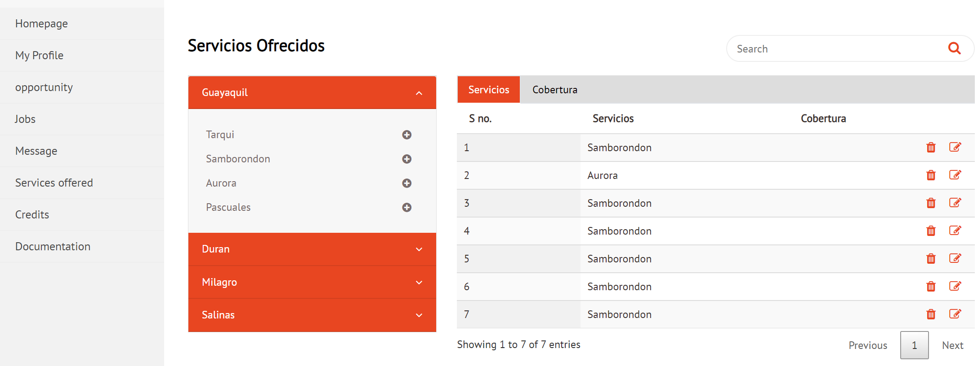

Credits

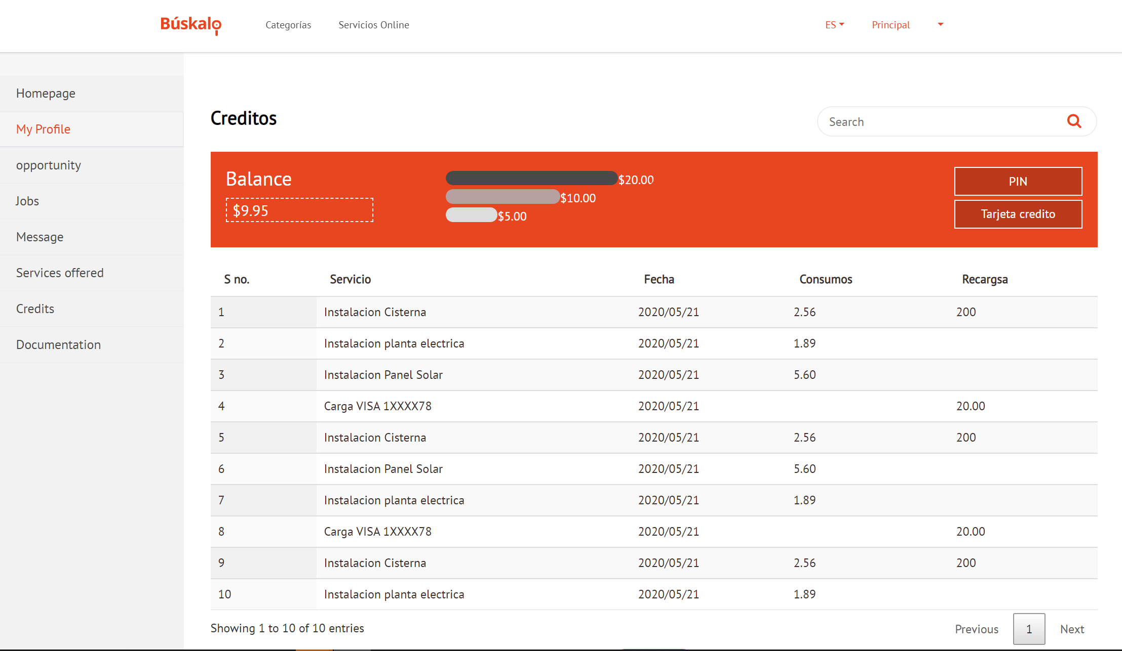

Documentation

no button or action works, we have not been able to upload the professional documentation

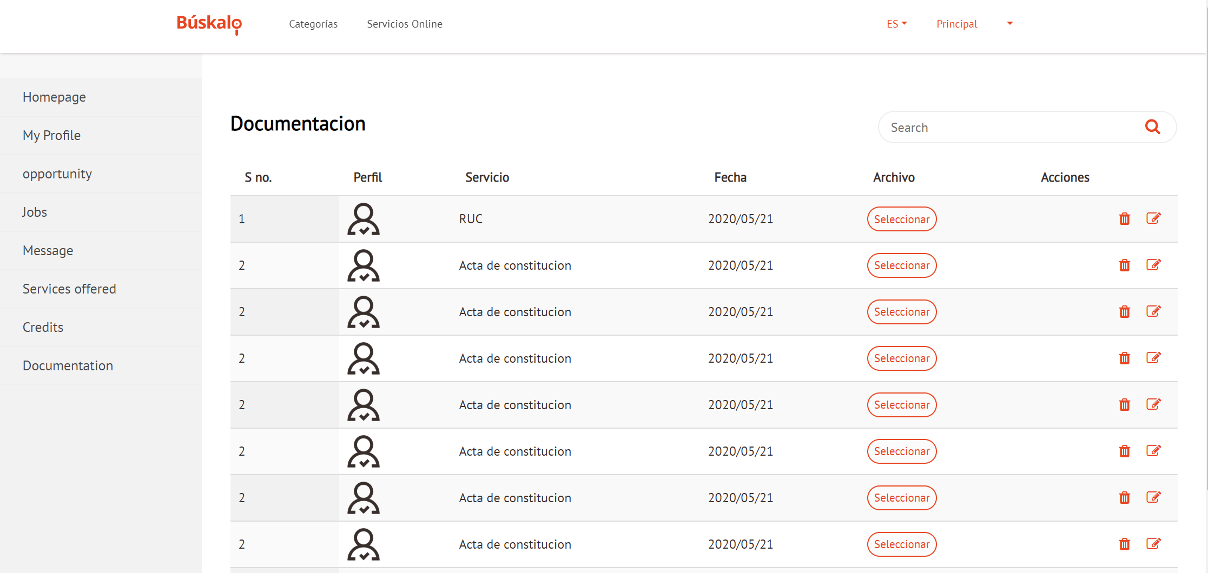

Register

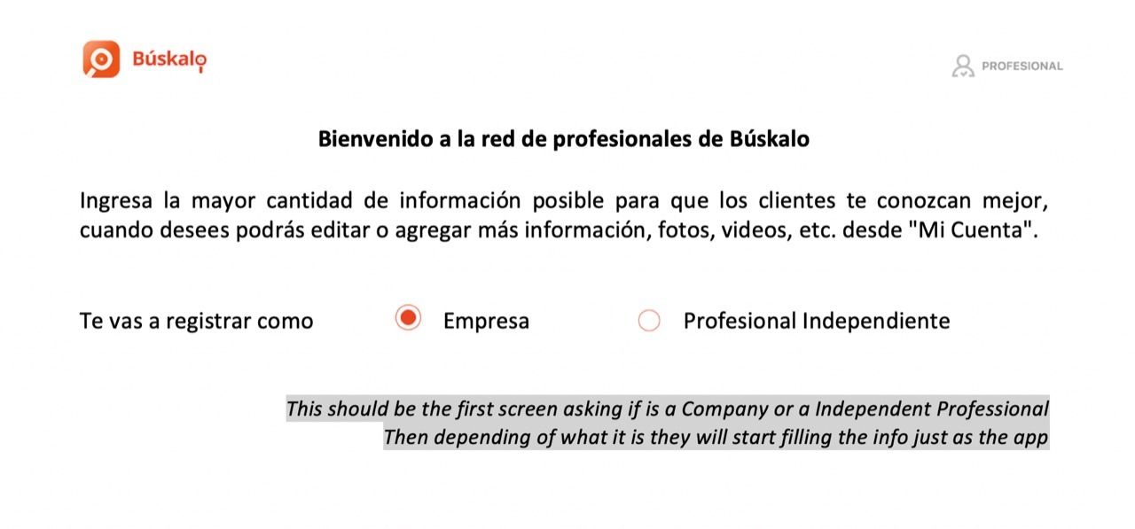

This is an example model of how to organize the inputs in the professional profile, consider that the information that is entered by professional or by company is different.

The idea that we present below is to have on the WEB a better distribution of the characteristics, services, payment methods, documents, etc.

